第二章 数列极限

题：

题1：
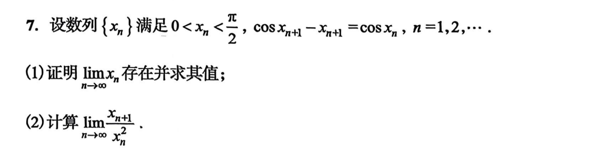
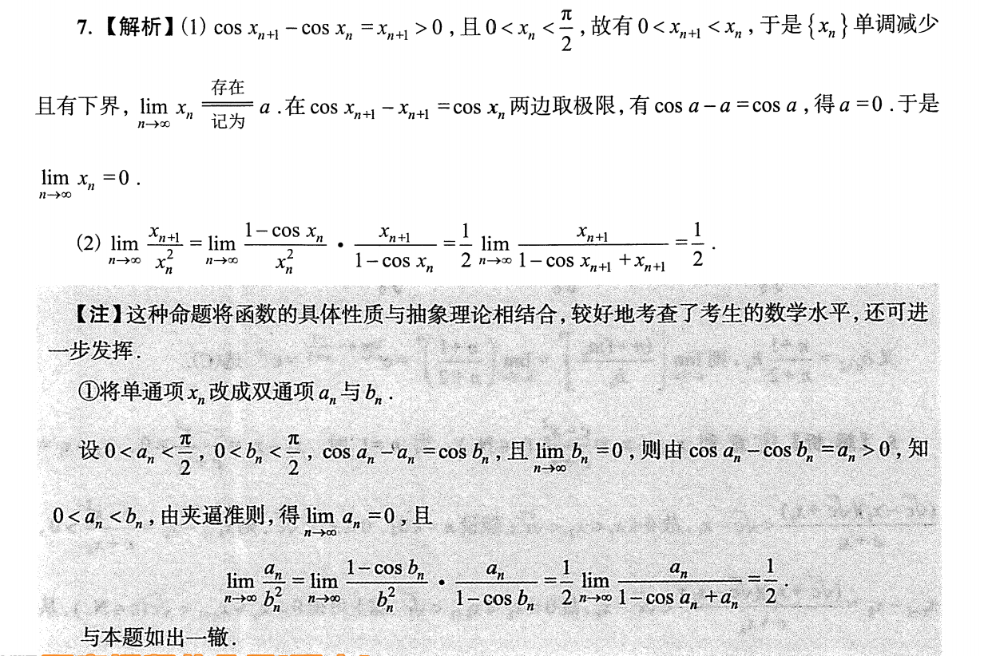
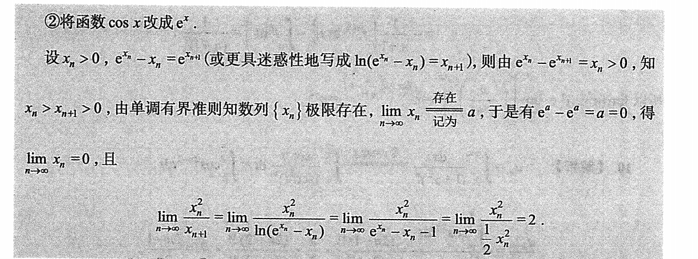

题2：
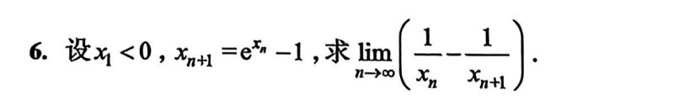
证明单调：https://chatgpt.com/g/g-p-6a1d505226e08191a7f47eb8e9418ffe-gao-shu-ocr/c/6a8191dc-6b90-83ee-a191-1789171118cd

题3：
https://chatgpt.com/g/g-p-6a1d505226e08191a7f47eb8e9418ffe-gao-shu-ocr/c/6a8196a6-fda8-83ee-86c7-a0e87e46819c

题4：
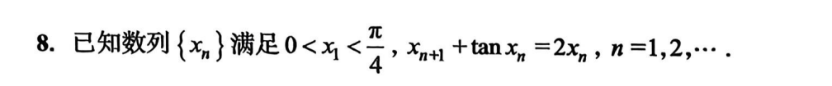
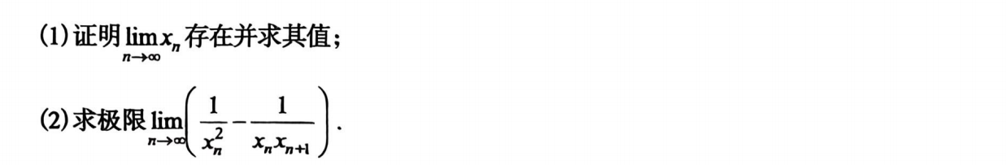
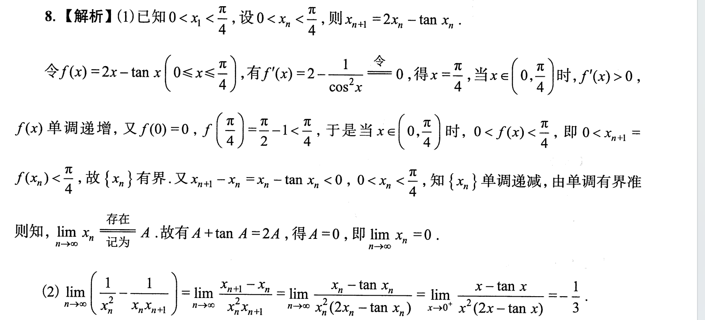
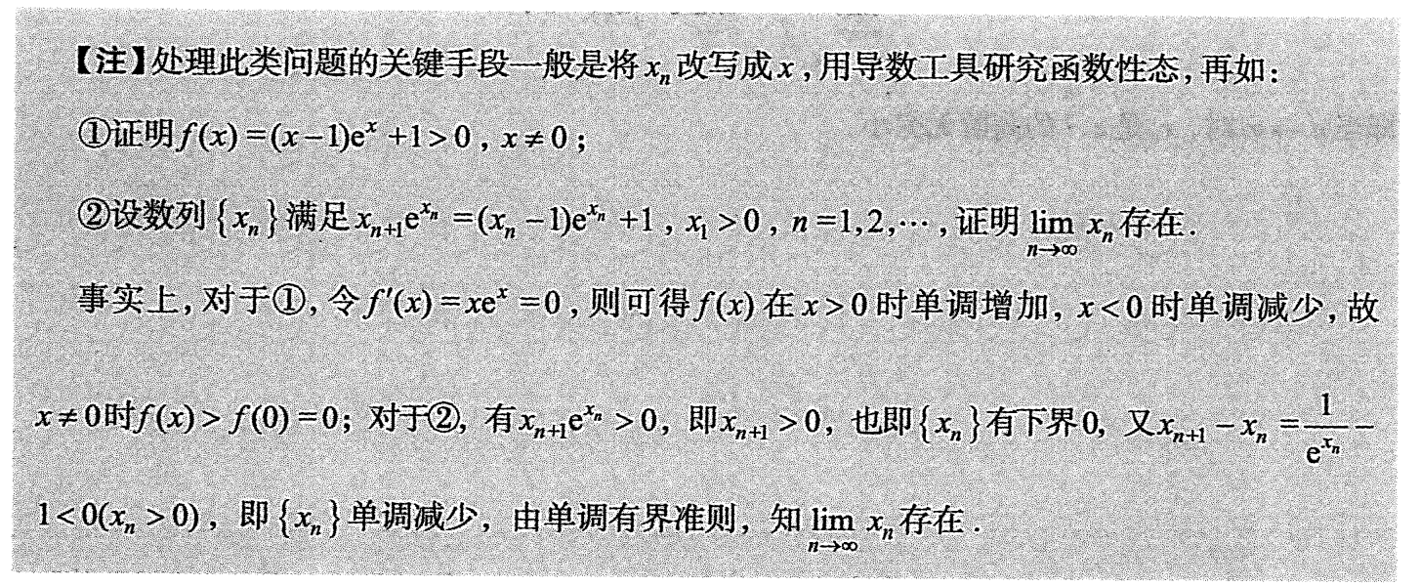

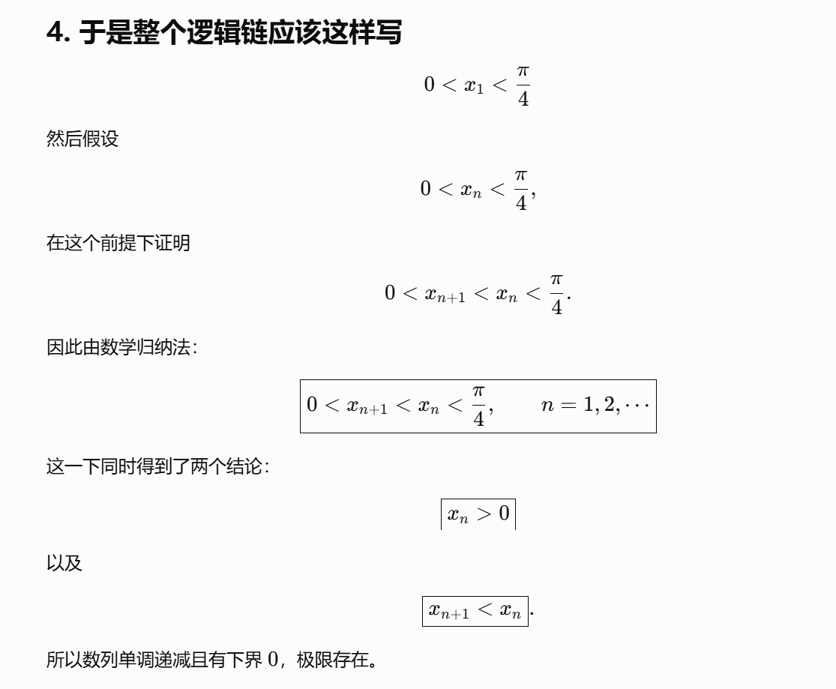
https://chatgpt.com/g/g-p-6a1d505226e08191a7f47eb8e9418ffe-gao-shu-ocr/c/6a81a1b3-225c-83ee-88fe-871ed5319926

题5：
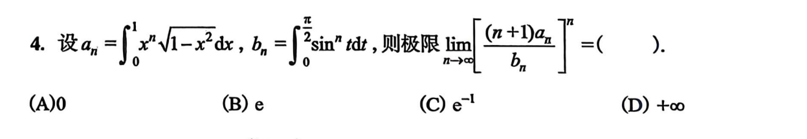
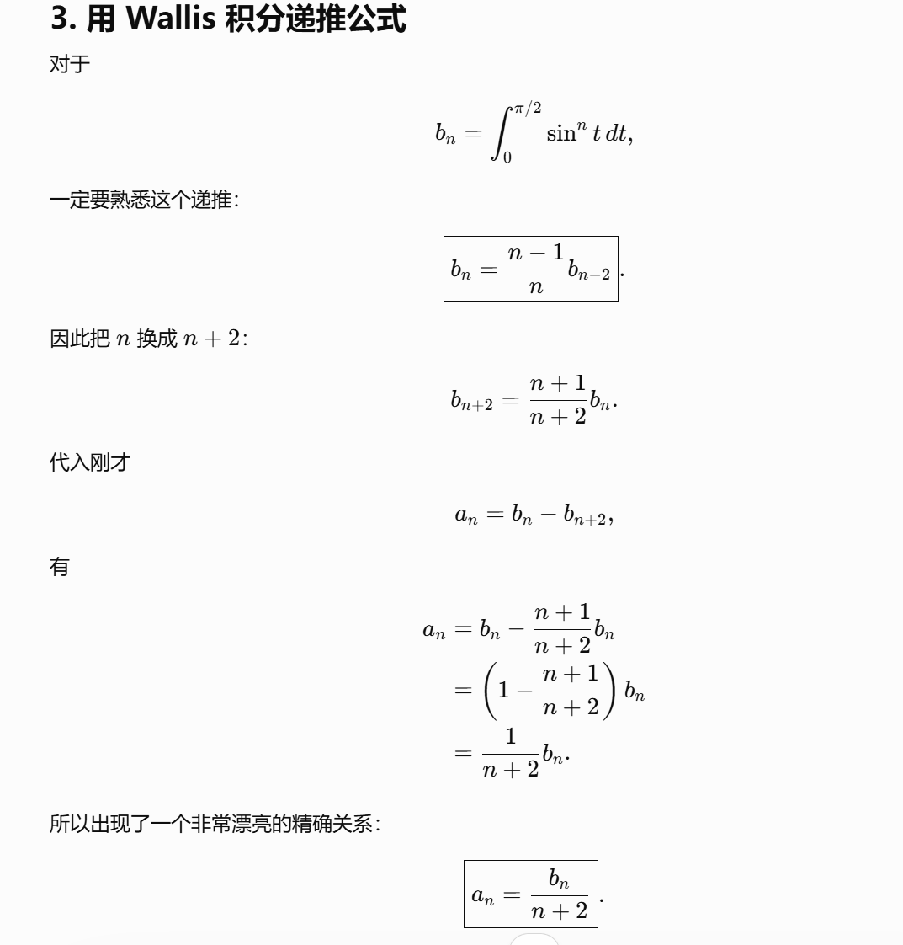

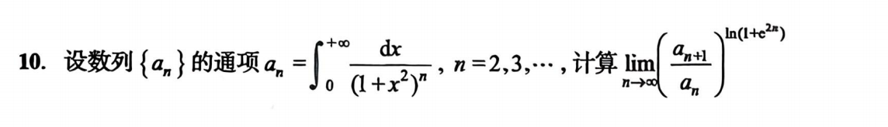
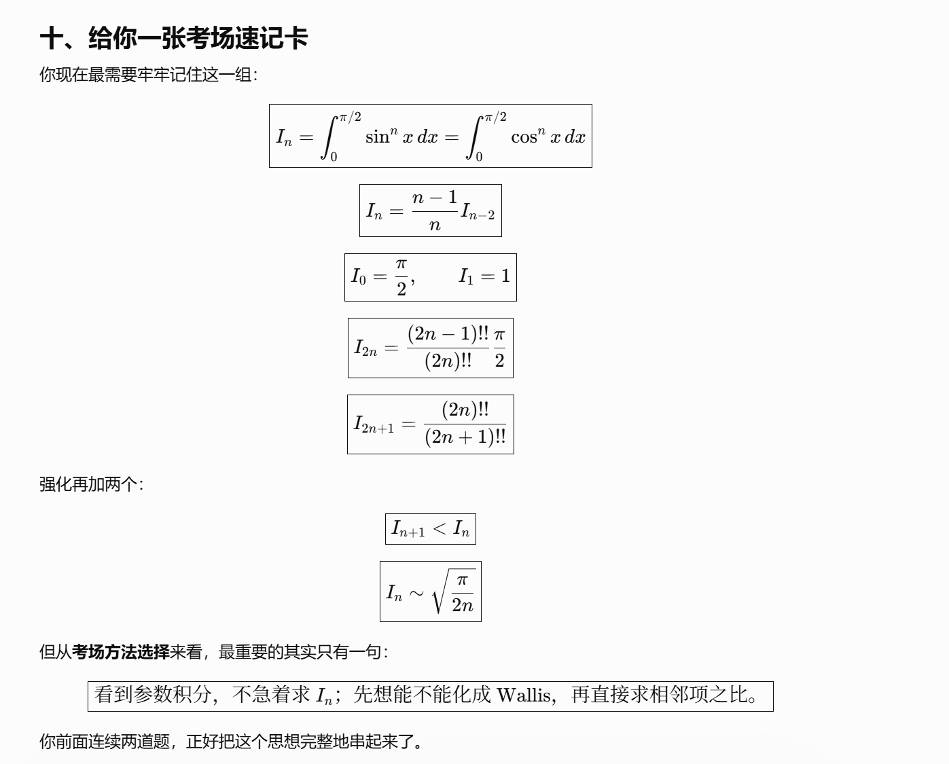
https://chatgpt.com/g/g-p-6a1d505226e08191a7f47eb8e9418ffe-gao-shu-ocr/c/6a827d5c-e4e0-83ee-9a51-57a6ed640c78

题6：
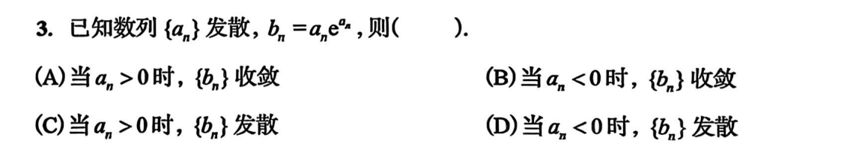
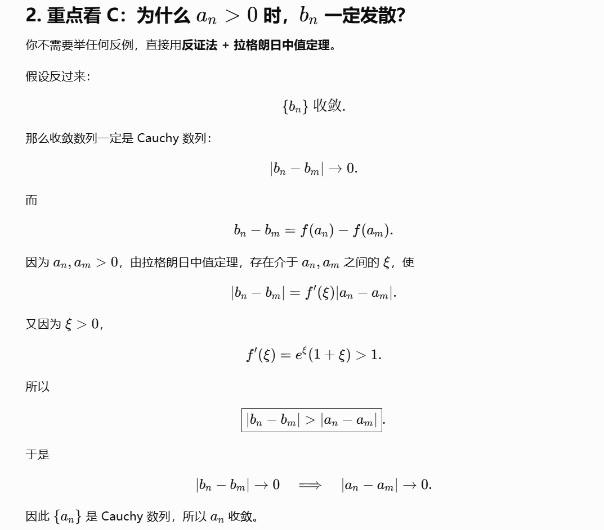
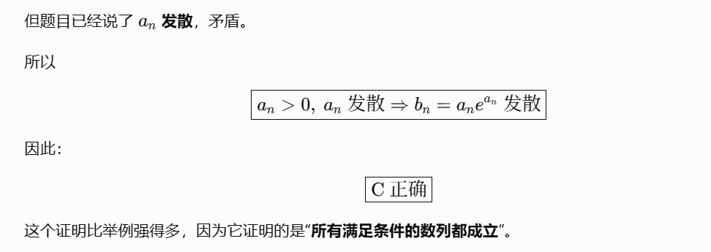
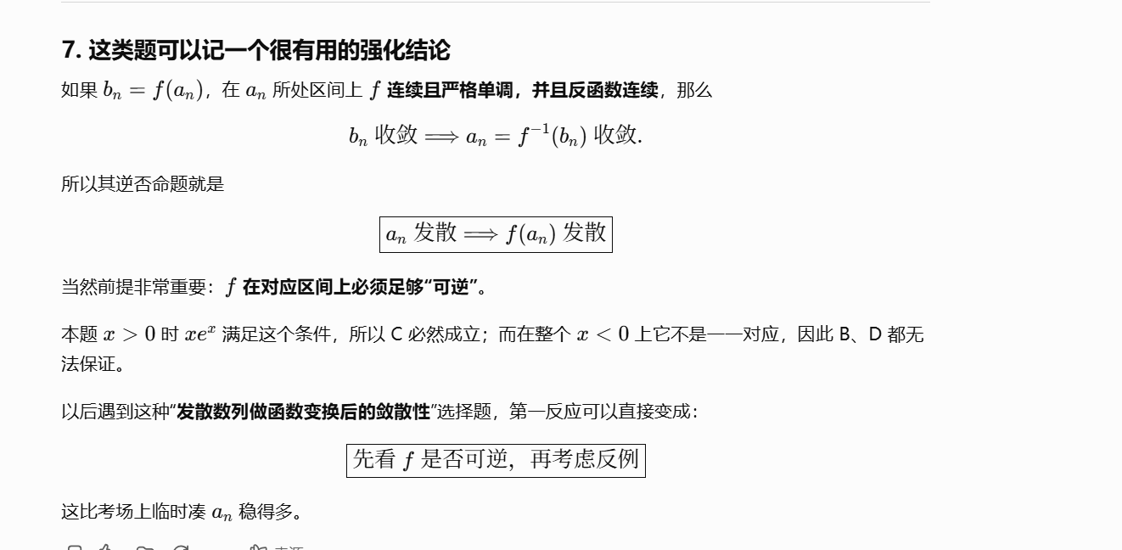

|（注：部分内容可能由 AI 生成）

